<!DOCTYPE HTML>

<HTML>

<head>

<meta charset="UTF-8">

<meta http-equiv="Content-type" content="text/html;charset=UTF-8">

<meta name="viewport" content="width=device-width, initial-scale=1">

<title>The YKV</title>

<link rel="stylesheet" type="text/css" href="css/Main.css">

<link rel="stylesheet" type="text/css" href="css/Home Page.css">

<link rel="stylesheet" type="text/css" href="css/Registration Forms.css">

</head>

<BODY>

<div id="holder">

<div id="top">

</div>

<div>

<h2><span><a href = "Home Page.html" id = "Logo"><img src="img/Logo.png" id = "Logo"></a></span></h2>

</div>

<div id="login">STAFF LOGIN</a></div>

<nav>

<ul id="mmenu">

<li><a href="Home Page.html">HOME</a></li>

<li><a href="#">ABOUT</a>

<ul>

<li><a href="At A Glance.html">VIT AT A GLANCE</a></li>

<li><a href="Achievements.html">ACHIEVEMENTS</a></li>

<li><a href="Placement.html">PLACEMENT</a></li>

<li><a href="Photo Gallery.html">PHOTO GALLERY</a></li>

<li><a href="Facilities.html">FACILITIES</a></li>

<li><a href="Contact.html">CONTACT US</a></li>

</ul>

</li>

<li><a href= "#" >PROGRAMMES</a>

<ul>

<li><a href="Graduate.html">GRADUATE</a>

<!--<ul>

<li><a href="Music.html">BTECH</a></li>

<li><a href="Videos.html">MED</a></li>

</ul>-->

</li>

<li><a href="Post Graduate.html">POST GRADUATE</a></li>

</ul>

</li>

<li><span class="current"><a href= "#" >ACADEMICS</a></span>

<ul>

<li><a href="Departments.html">DEPARTMENTS</a></li>

<li><a href="Curriculum.html">CURRICULUM / SYLLABI</a></li>

<li><a href="Academic Calendar.html">ACADEMIC CALENDAR</a></li>

</ul>

</li>

<li><a href="#">STUDENTS</a>

<ul>

<li><a href="Curriculum.html">CURRICULUM / SYLLABI</a></li>

<li><a href="Time Table.html">TIME TABLE</a></li>

<li><a href="Holidays.html">LIST OF HOLIDAYS</a></li>

<li><a href="Noticeboard.html">STUDENT NOTICEBOARD</a></li>

<li><a href="Results.html">RESULTS</a></li>

<li><a href="Attendance Rules.html">ATTENDANCE RULES</a></li>

<li><a href="Grievance.html">GRIEVANCE FORM</a></li>

</ul>

</li>

<!--<li><a href="#">STAFF</a></li>-->

</ul>

</nav>

<div id="rside">

<div id="mtird">

<p>

ADMISSIONS OPEN NOW ! <br> <br>

<font color = '#FFBD00'>_________ </font><br><br>

BBA Counselling in progress : New Students Jam Up The Corridors ! <br><br>

<font color = '#FFBD00'>_________ </font><br><br>

FEE SUBMISSION : Last Date for Fee Submission has been extended to 5th August, 2016 (Friday). <br><br>

<font color = '#FFBD00'>_________ </font><br><br>

New Session starts from 1st August, 2016 (Monday).<br><br>

<font color = '#FFBD00'>_________ </font><br><br>

</p>

</div>

<div id="ltird">

<left>

<a href="New Students.html">NEW STUDENTS »</a>

<br><br>

<a href="Hiring.html">WE ARE HIRING »</a>

</left>

</div>

</div>

<div id="center">

<div id="scrdiv">

<br><br><br><br><br><br>

<div id="headiv">

<!--<left>

<span id="heading"><b>&nbsp;BEST ONLINE UNIVERSITY</b></span>

<hr><br>

VIT College offers Under Graduate and Post Graduate level full time Professional programs approved by AICTE in affiliation with VIT UNIVERSITY, Vellore.

<br><br>

<br><br> vit univeristy of virtual interactive eductation, vellore was established in the year 1969. VIT College has a material designed campus spread all over the globe.

<br><br><br>

</left>-->

<div id="leftdiv">

<span id="inheading"><b>OUR PATRONS</b></span>

<hr>

<br>

<img src="img/a.jpg" height="80px" width="80px" id="roleimg" >

<br>

<span id="rottnr1">prj</span>

<br>

<span id="rottnr2">CEO</span>

<hr>

<br>

<br>

<img src="img/b.jpg" height="80px" width="80px" id="roleimg" >

<br>

<span id="rottnr1">prj</span>

<br>

<span id="rottnr2">CHAIRPERSON</span>

<hr>

<br>

<br>

<img src="img/t.jpg" height="80px" width="80px" id="roleimg" >

<br>

<span id="rottnr1">[rj</span>

<br>

<span id="rottnr2">DIRECTOR</span>

<hr>

<br>

<br>

<img src="img/l" height="80px" width="80px" id="roleimg" >

<br>

<span id="rottnr1">preeti rachel</span>

<br>

<span id="rottnr2">PRINCIPAL</span>

<br>

<hr>

<br>

<!--<div id="rdm">some random text</div>-->

<!--<hr><br><br>

<center>

<div id="frame">-->

<!--<iframe src="https://visualantidote.ap2.visual.force.com/apex/FormdraftPreview?id=a0d2800000253tuAAA" height="586px" width="100%"></iframe>-->

<!--<script type="text/javascript" id="jsFastForms" src="https://fastforms.visualantidote.com/FormEngine/Scripts/Main.js?d=PzCCLNh%2fNeWWpbCyPuOwcR5owlDtbnQX5%2fM3bSRF24nlY2XqU2GTUFOBD0Em3rHP" height="585px" width="100%"></script>

</div>

</center>-->

<!--<br><br><hr>-->

</div>

<div id="formdiv">

<div id="sturegframe">

<script type="text/javascript" id="jsFastForms" src="https://fastforms.visualantidote.com/FormEngine/Scripts/Main.js?d=PzCCLNh%2fNeWWpbCyPuOwcR5owlDtbnQX5%2fM3bSRF24mxl1Kyu%2fNb2uB6HusAdGVp">

</script>

</div>

<!--<span id="inheading"><b>VIT ACHIEVEMENTS</b></span>

<hr>

<br>

<br>

<div id="highltin">

» Students have brought laurels to the college by winning a total of 13 Gold Medals.

<br><hr><br>

» ECE department got a sponsored project titled “Hybrid Satellite Terrestrial Communication: Algorithm Design & Performance Analysis” for an amount of Rs.36.92 Lakh from Department of Science & Technology (DST), Govt. of India, New Delhi.

<br><hr><br>

» 'All Terrain Vehicle' & Thunder Bolt developed by the Students was displayed at Auto Expo 2010 & 2014 respectively and awarded by the University.

<br><hr><br>

» Civil Department got a consultancy from CPWD, Central Govt. for an amount of Rs.60,000/- to make a Structural Design for Erection of Temporary Earth retain structure using soldier piles/H-beams.

<br><hr><br>

» Placement of more than 85% eligible Students in 2015-16.

<br><br>

<hr>

<br><br><br>

</div>-->

</div>

<!--<div id="newdiv">

<br><br>

<span id="inheading"><b>HEADING 'N' - Change Text</b></span>

<hr><br>

<div id="highltin">

<span id="rott3">Approved by: AICTE</span>

<br>

<hr>

<br>

<span id="rott3">Accreditated by: NAAC</span>

<br>

<hr>

<br>

<span id="rott3">Affiliated to: VIT GROUP OF INSTITUTIONS, New Delhi</span>

<br>

<hr>

<br>

<span id="rott3">ISO 9001:2008 Certified</span>

<br>

<hr>

<br>

<span id="rott3">EN ISO 14001:2004 Certified</span>

<br>

<hr>

<br>

</div>

</div>-->

<br><br><br>

<!--<hr>-->

</div>

</div>

<div id="bottom"></div>

</div>

</div>

</BODY>

</HTML>

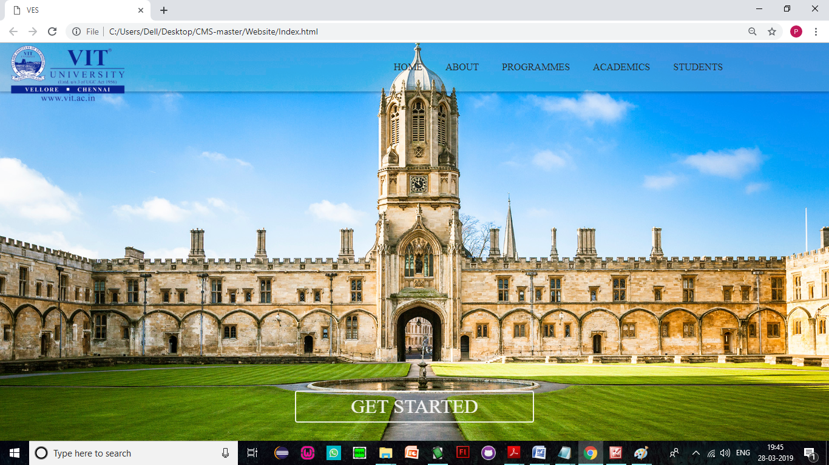

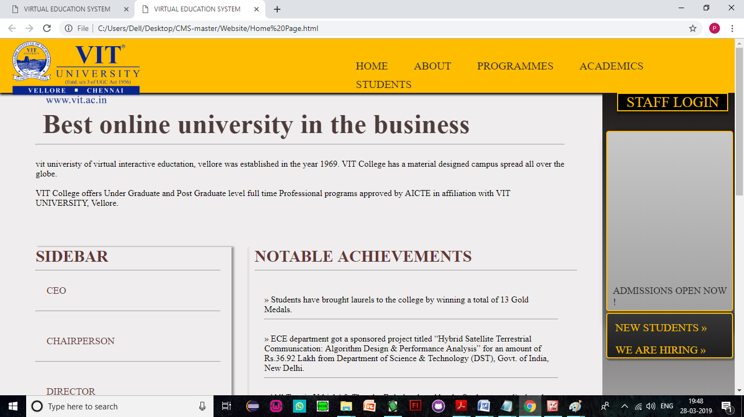

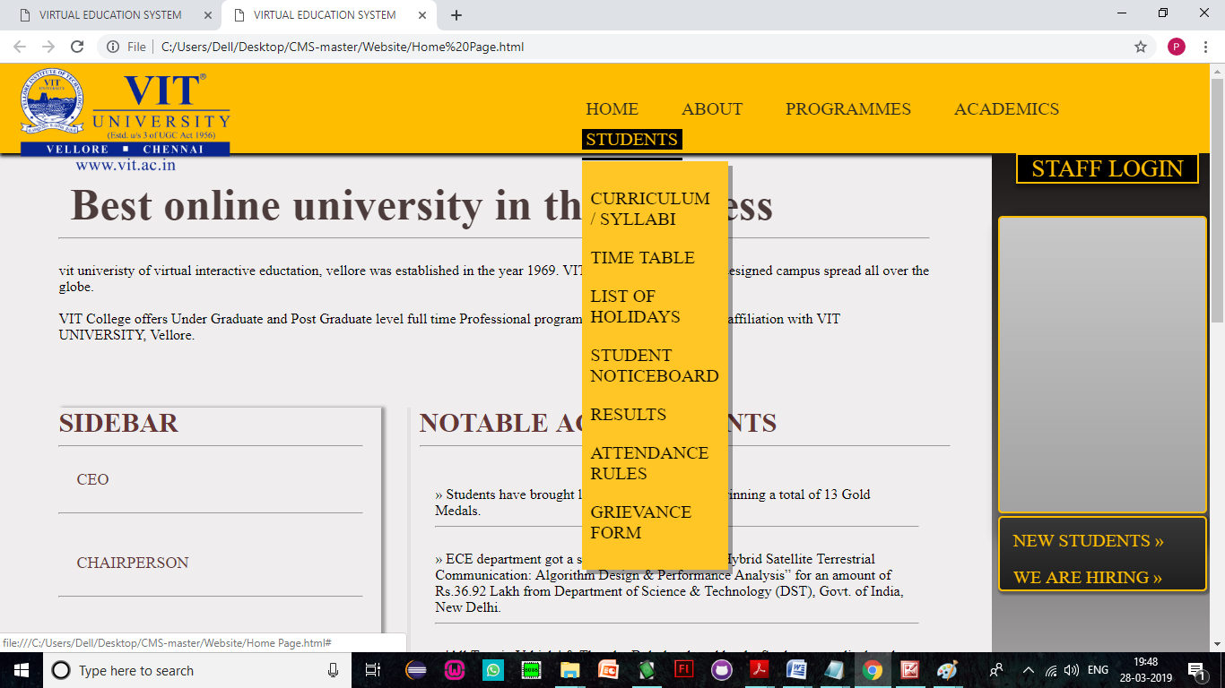

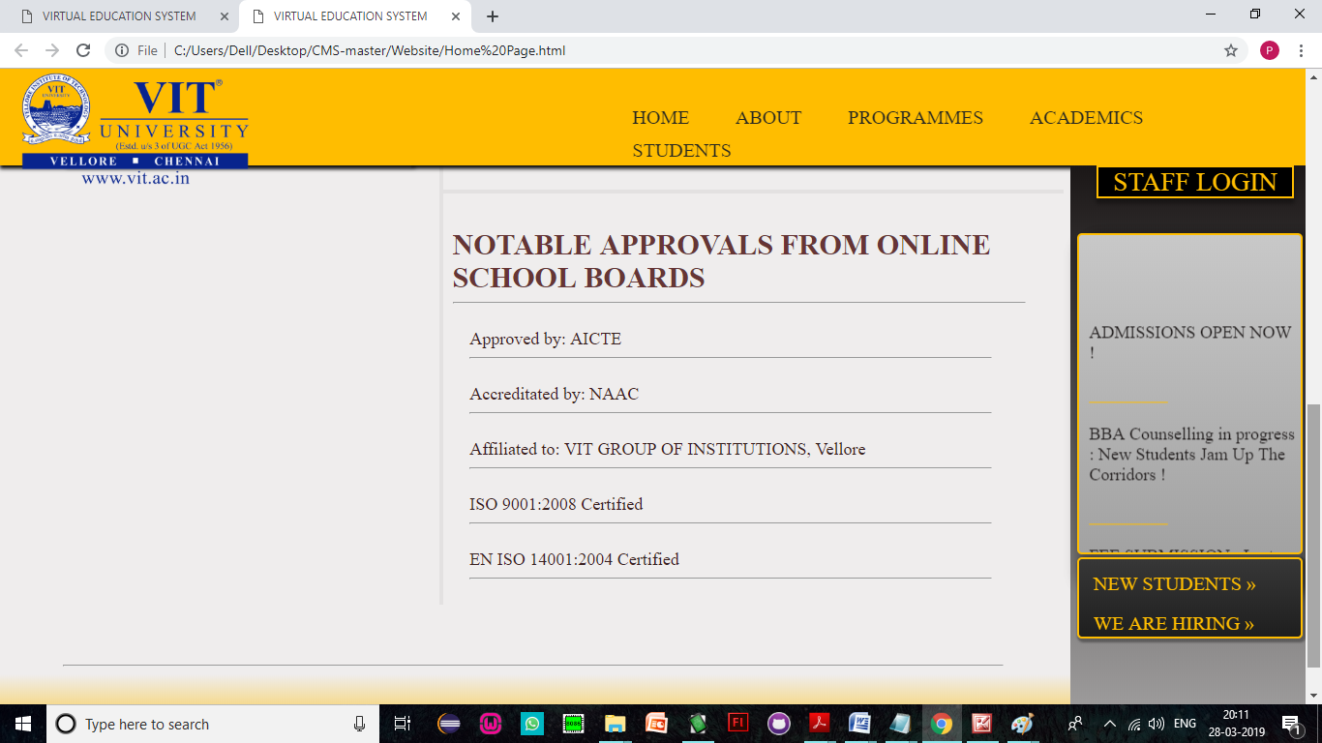

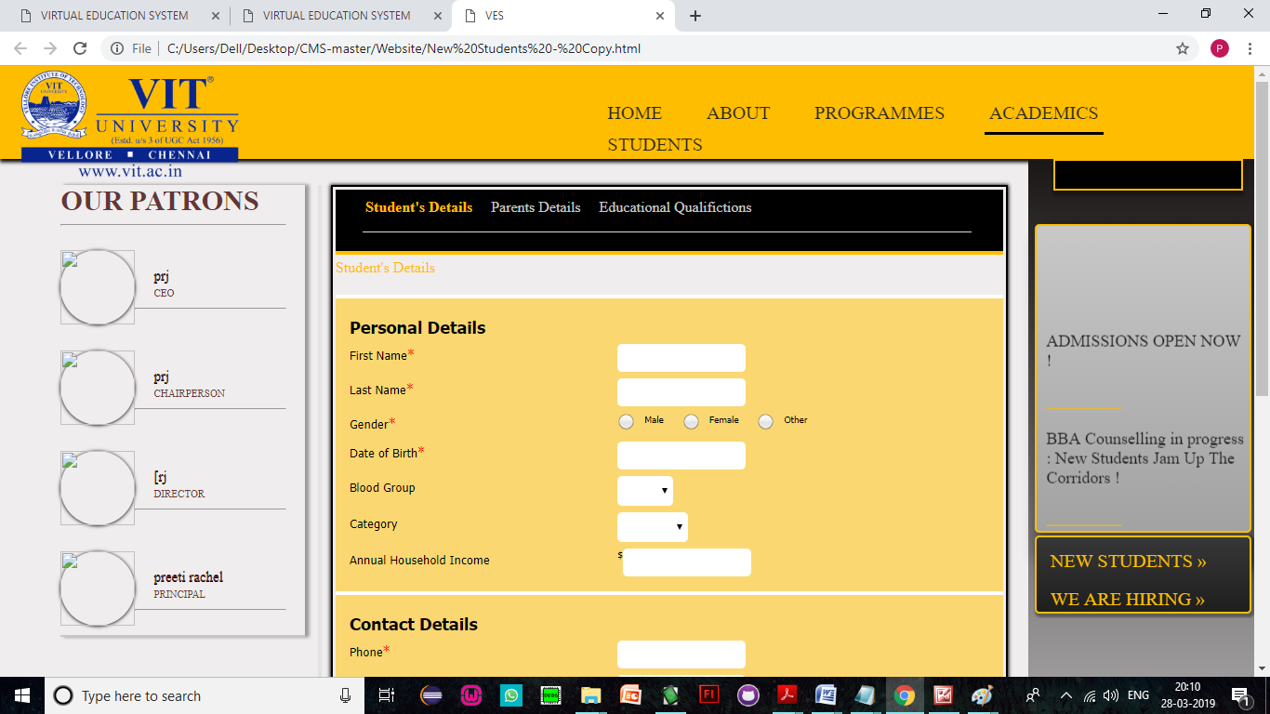

<!DOCTYPE HTML>

<HTML>

<head>

<meta charset="UTF-8">

<meta http-equiv="Content-type" content="text/html;charset=UTF-8">

<title>VES</title>

<link rel="stylesheet" type="text/css" href="css/Index.css">

</head>

<BODY>

<div id="top">

</div>

<div>

<h2><span><a href = "Home Page.html" id = "Logo"><img src="img/Logo.png" id = "Logo"></a></span></h2>

</div>

<nav>

<ul id="mmenu">

<li><a href="Home Page.html" class = "home">HOME</a></li>

<li><a href="About.html">ABOUT</a>

<ul>

<li><a href="New Student.html">VIT AT A GLANCE</a></li>

<li><a href="Current Student.html">ACHIEVEMENTS</a></li>

<li><a href="Alumni.html">PLACEMENT</a></li>

<li><a href="Alumni.html">PHOTO GALLERY</a></li>

<li><a href="Alumni.html">FACILITIES</a></li>

<li><a href="Alumni.html">CONTACT US</a></li>

</ul>

</li>

<li><a href= "#" >PROGRAMMES</a>

<ul>

<li><a href="Music.html">GRADUATE</a>

<!--<ul>

<li><a href="Music.html">BTECH</a></li>

</ul>-->

</li>

<li><a href="Videos.html">POST GRADUATE</a></li>

</ul>

</li>

<li><a href= "#" >ACADEMICS</a>

<ul>

<li><a href="Music.html">DEPARTMENTS</a></li>

<li><a href="Videos.html">CURRICULUM / SYLLABI</a></li>

<li><a href="Calendar.html">ACADEMIC CALENDAR</a></li>

</ul>

</li>

<li><a href="#">STUDENTS</a>

<ul>

<li><a href="New Student.html">CURRICULUM / SYLLABI</a></li>

<li><a href="Current Student.html">TIME TABLE</a></li>

<li><a href="Alumni.html">LIST OF HOLIDAYS</a></li>

<li><a href="Alumni.html">STUDENT NOTICEBOARD</a></li>

<li><a href="Alumni.html">RESULTS</a></li>

<li><a href="Alumni.html">ATTENDANCE RULES</a></li>

<li><a href="Alumni.html">GRIEVANCE FORM</a></li>

</ul>

</li>

<!--<li><a href="#">STAFF</a></li>-->

</ul>

</nav>

<center>

<button id="GetS">

<span><a href="Home Page.html">GET STARTED</a></span>

</button>

</center>

<!--<div id="lside">left</div>-->

<!--<div id="center">center</div>-->

<!--<div id="rside">GHello</div>-->

<!--<div id="bottom">Hello</div>-->

</BODY>

</HTML>

